

Perfect Game SEC: Alabama | Georgia | North Carolina | South Carolina | Tennessee | Virginia

Dominick J. Ferraro
(864) 447-5777
Dferraro@perfectgame.org

July 29, 2025

Subject: Letter of Recommendation for Trey Glover

Dear Mr. Madden & Miss. Eaker,

It is with immense pleasure and without reservation that I recommend Trey Glover for the position of Director of Parks, Recreation and Tourism. I have had the privilege of knowing and working alongside Trey for the past seven years, and in that time, I have consistently been impressed by his profound understanding of the field and his exceptional personal qualities.

Trey possesses an extraordinary depth of knowledge when it comes to parks, recreation, and tourism management. He has a keen eye for operational efficiency, program development, and community engagement. Throughout our professional relationship, I have witnessed his ability to navigate complex challenges, implement innovative solutions, and consistently achieve outstanding results. His dedication to enhancing public spaces and recreational opportunities is evident in every project he undertakes. He not only knows the intricacies of the job but also demonstrates a forward-thinking approach to the evolving needs of the community and its economic impact.

Beyond his impressive professional acumen, Trey is, quite simply, a great person. He approaches his work and interactions with integrity, enthusiasm, and a genuine commitment to collaboration. He is a natural leader who inspires confidence and respect among his colleagues and subordinates. His interpersonal skills are excellent, making him highly effective in building relationships with stakeholders, staff, and the public. Trey's positive attitude and approachable demeanor make him a true asset to any organization.

I am confident that Trey Glover's expertise, leadership, and outstanding character make him an ideal candidate for this role. He would undoubtedly bring significant value and a positive impact to the City of Greenville.

Please do not hesitate to contact me if you require any further information or wish to discuss Trey's qualifications in more detail.

Sincerely,

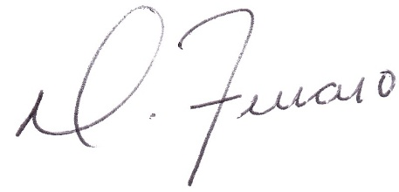

Dominick Ferraro
Perfect Game SEC, Managing Partner

