
Perfect Game SEC: Alabama | Georgia | North Carolina | South Carolina | Tennessee | Virginia

December 18, 2024

Subject: Contract Proposal & Compensation Package

Position: High School State Director (North & South Carolina)

Proposed Compensation: To retain teams for tournaments for 14u to 18u, we propose a competitive compensation package that includes one of the following:

- Base Salary: The Employee shall receive an annual base salary of $95,000, payable in thirteen (13) weekly installments of approximately $7,307.69 each, commencing on May 19, 2025, and concluding in November 2025.

- Base Salary & Bonus Structure: The Employee shall receive an annual base salary of $50,000, payable in thirteen (13) weekly installments of approximately $3,846.15 each, commencing on May 19, 2025, and concluding in November 2025.

In addition to the base salary, the Employee shall be eligible for a bonus, the amount of which will be determined based on the below criteria and made payable in the fourth quarter: (Bonuses are not cumulative.)

  - $20,000 Bonus if profits exceed $300,000
  - $30,000 Bonus if profits exceed $500,000
  - $40,000 Bonus if profits exceed $750,000
  - $80,000 Bonus if profits exceed $1,000,000

- Baseline Retention & NET Revenue Share: The Employee shall retain a base salary of $50,000 per year. In addition, the Employee shall receive a commission equal to 25% of the net revenue generated from sales in North and South Carolina.

Rationale:

Key Performance Indicators (KPIs):
To ensure fair and accurate measurement of performance and bonus eligibility, we propose the following KPIs:

- Participant Satisfaction: This KPI measures how satisfied participants, including players, coaches, and parents, are with the tournament experience. It can be measured through surveys, feedback forms, or online reviews.
- Financial Performance: This KPI tracks the financial success of the tournament. It includes metrics like total revenue, total expenses, and net profit. It also measures the efficiency of budget management and revenue generation.
- Tournament & Team Completion Rate: This KPI measures the percentage of scheduled games that are completed. It reflects the director's ability to manage logistics, weather conditions, and other unforeseen challenges to ensure the smooth running of the tournament.

Bonus Calculation: A performance-based bonus will be calculated annually, contingent upon the company's net profits realized within your designated regions for the fiscal year. Such bonuses will be paid out in December.

Director Protection Clause: All fields currently titled in Jake Willards name will remain titled for the duration of this specific agreement.

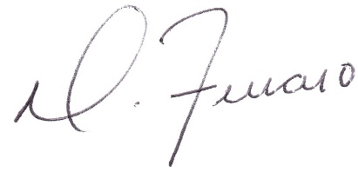

Dominick J. Ferraro
Perfect Game SEC, Managing Partner

Upstate, SC: pgupstate@perfectgame.org Charlotte, NC: pgcharlotte@perfectgame.org Triangle, NC: pgtriangle@perfectgame.org
Western, NC: pgwesternnc@perfectgame.org Triad, NC: pgtriad@perfectgame.org



