
Status as of: April 16, 2025

Perfect Game SEC: Alabama | Georgia | North Carolina | South Carolina | Tennessee | Virginia

April 16, 2025

Dear Parents, Coaches & Players:

I hope this letter finds you well.

I am writing to address recent misinformation circulating on social media regarding the status of my tournaments in North Carolina. Despite these false claims, I want to assure you that I am continuing to host tournaments, and participation numbers remain stronger than ever in the Triad and the entire Eastern part of North Carolina.

It has come to my attention that a competitor has been disseminating inaccurate information, both on their social media platforms and through direct contact with coaches and parents, in an attempt to damage my reputation and tournaments.

Specifically, regarding the Kinston market, I want to confirm that I am still organizing events there. I have fulfilled all field rental obligations and expenses for the past five years. I possess documentation, including dated agreements and proof of payment from my company to Kinston Parks and Recreation, to substantiate this.

Regrettably, I am now compelled to seek legal counsel to address my competitor's unethical practices. I want to reassure everyone that I am committed to hosting tournaments in the Downeast region each weekend. Recent participation numbers demonstrate the continued success of these events, with 60 teams participating last weekend and over 41 teams expected this coming weekend.

I urge you to contact me directly with any questions or concerns before accepting the validity of any statements made by my competitor, whether shared personally or on social media.

Many of you have known and supported me for years. My decision to partner with Perfect Game was driven by a desire to offer teams a superior product, and the initial response has been overwhelmingly positive.

Thank you for your continued support. I look forward to a successful 2025 season!

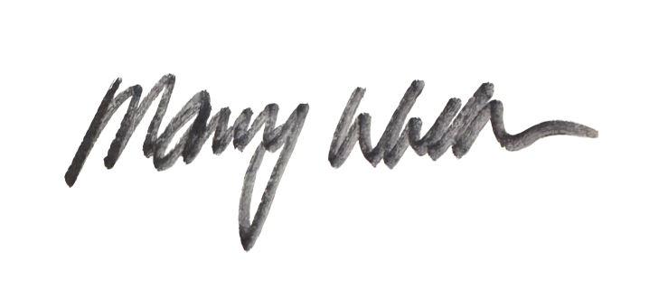
Mary Williams
Perfect Game SEC Softball, Managing Partner

