
Status as of: September 4, 2025

Perfect Game SEC: Alabama | Georgia | North Carolina | South Carolina | Tennessee | Virginia

Subject: Facility development and economic impact and providing a network of partnerships.

Perfect Game and its partner, Sports Facilities Companies (SFC), can help Greenwood improve its sports facilities and attract tourism by leveraging their expertise and extensive network. The document details the partnership between Perfect Game and SFC and how The City of Greenwood would benefit.

Perfect Game

- Mission and Reach: Perfect Game is the "world's premier youth diamond sports platform" and the "biggest media ecosystem in youth baseball & soon to be softball". Over 2 million participants in 2025.

Sports Facilities Companies (SFC)

- Mission: SFC's mission is to "improve the health & economic vitality of the communities we serve".
- Services: SFC offers a range of services, including planning, finance support, development, and even the management for sports facilities.
- Network: SFC manages over 70 facilities in more than 36 states, forming the "single largest sports tourism network" in the U.S.

Partnership and Economic Impact

- Economic Impact: By hosting tournaments, the partnership can attract a large number of visitors to Greenwood.
- Facility Development Expertise: SFC provides services for venue planning and development. Perfect Game has a history of partnering to develop new complexes or renovate existing ones, including the installation of new turf fields.
- Strategic Partnerships: Perfect Game has partnered with other entities to make capital improvements to facilities. For instance, an agreement with East Cobb Baseball included the installation of artificial turf on all eight regulation fields at the complex. Perfect Game also worked on a project to build a new national headquarters complex with "16 lighted all-weather turf fields".
- Economic Viability: Turf fields are a valuable investment for a community because they are durable, easy to maintain, and can be used for various sports. This increased usage and the ability to host more events and tournaments can generate revenue from rentals, sponsorships, and local business activity.

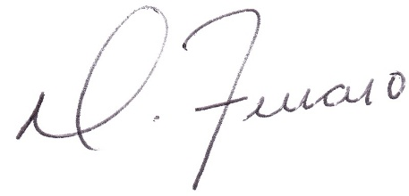
Dominick J. Ferraro
Perfect Game SEC, Managing Partner

